UPPER BODY EXERCISES FOR SPLIT ROUTINE

WELLNESS 10 (Ms. Lynch)

Flat Bench Press
Prime movers/Muscles worked: Pectoralis major, anterior deltoids, deltoid
* This exercise can be performed using dumbbells and/or with free weights. (always have a spotter for this exercise)
Beginning Position:
- Lie face up on a bench with feet flat on the floor.
- Eyes should be below the edge of the bar.
Upward Movement Phase:
- Grasp the bar with a closed, pronated grip, and remove the bar off the shelf.
Downward Movement Phase: 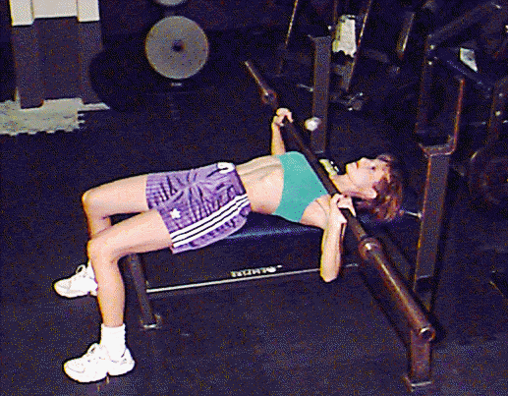
- Lower bar/free weights slowly and with control to the chest keeping the wrists straight.

Push Up
Prime movers/Muscles worked: Pectoralis major, anterior deltoids, deltoid
Beginning Phase: 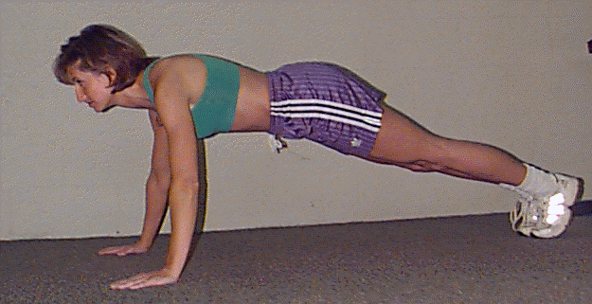

- Start face-down on the floor with arms extended and shoulder width apart, back flat and feet together.
Movement Phase: 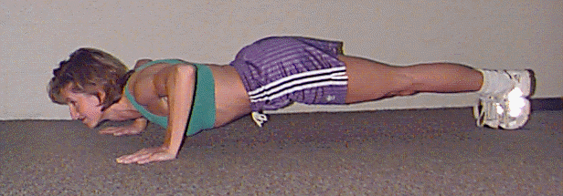

- Lower body towards the floor until chest just touches floor, while keeping back parallel to the floor.
Ending Phase:
- Push your body back to starting position slowly and with control until your elbows are fully extended.

Lat Pulldown
Prime movers/Muscles worked: Latissimus dorsi
Beginning Phase:
- Grasp the bar with a closed, pronated grip that is wider than shoulder width apart.
Downward Phase:
- With torso erect, head slightly down and arms fully extended slowly pull the bar down slightly touching the base of the neck.
Upward Phase:
- Control the bar during the upward phase allowing the arms to fully extend.

Bicep Curl
Prime Movers/Muscles worked: Biceps and elbow flexors
* These exercises can be done with a bar, free weights, or as an alternative, water bottles.
Beginning Phase: 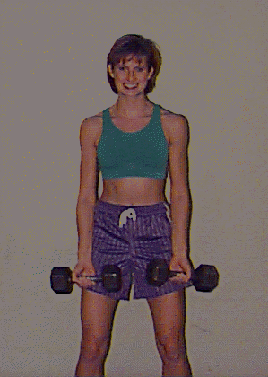
- Grasp the bar with a closed, supinated grip that is slightly wider than shoulder width apart. Stand erect with feet shoulder width apart and knees slightly bent.
Movement Phase: 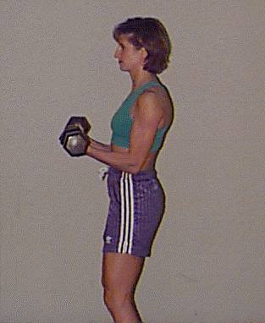
- Raise the bar in an arc by bending arms at the elbow moving upward to the front of the shoulders
- (Do not swing the bar).
- Lower the bar in a slowly with control until the arms are fully extended.

Hammer Curls
Prime movers/Muscles worked:
* This exercise can be performed with free weights or as an alternative water bottles can be used.
Beginning Phase: 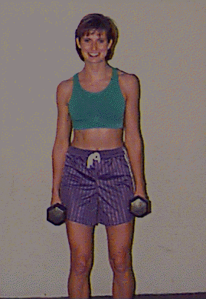

- Grasp the dumbbells with a closed, neutral grip with the palm of the hand facing the outer thighs. Stand erect with feet shoulder width apart and knees slightly bent.
- Arms should be fully extended with dumbbells hanging at the sides.
Upward Phase: 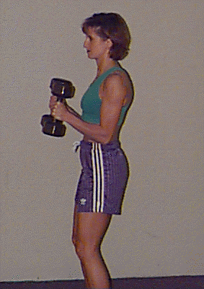

- Raise one dumbbell at a time by slowly bending at the elbow, bring the dumbbell to the front of the shoulder.
- Alternate arms.
Downward Phase:
- Lower the dumbbell in a slow, controlled movement until the arm is fully extended.

Tricep Pulldown
Prime Movers/Muscles worked: Triceps
Beginning Phase:
- Grasp the bar with a closed, pronated grip that is about 10-15 cm apart.
- Feet should be shoulder width apart with knees slightly bent and torso erect.
Movement Phase:
- Arms should be bent at the elbows, pull the bar down slowly toward the lower trunk of the body without forcefully extending the elbows.
- Allow the bar to raise slowly under control until you are at start position.

Tricep Extension
* This exercise can be done with free weights or water bottles.
* This exercise can be done standing or using a bench for support.
Beginning Phase: 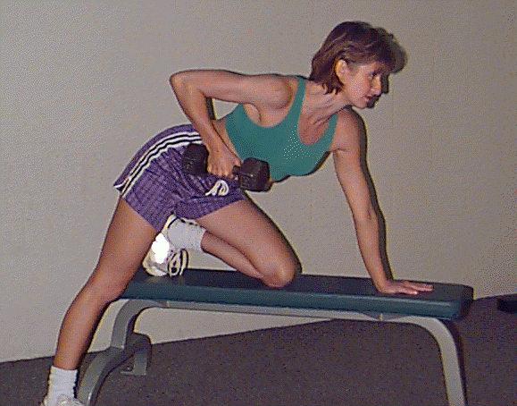

- Place one hand on opposing leg or a bench for support with the other leg on the floor for stability.
Movement Phase: 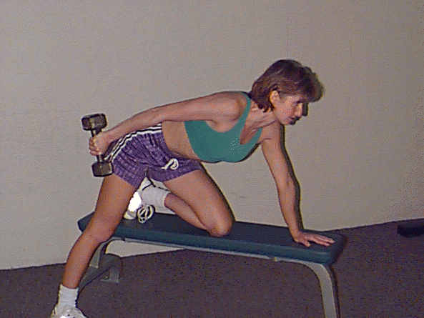

- Raise the weight up to the front of the body at hip height by bending the arm at the elbow.
- Straighten elbow so that the weight is at the back of the body.

Flat Dumbbell Fly
Prime Movers/Muscles worked: Pectoralis major
Beginning Position: 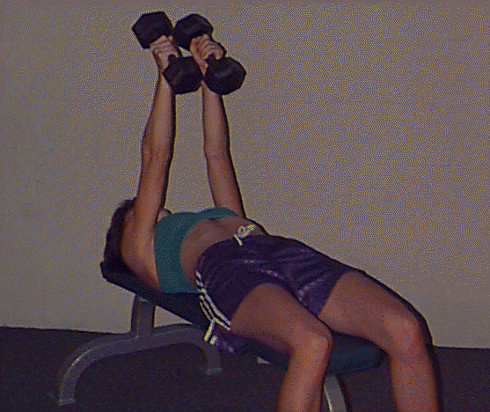
- Lie face up flat on a bench
- Grasp dumbbells
- Press dumbbells straight up over your chest keeping your palms facing each other
- Point elbows out and keep them slightly flexed
Downward Movement Phase: 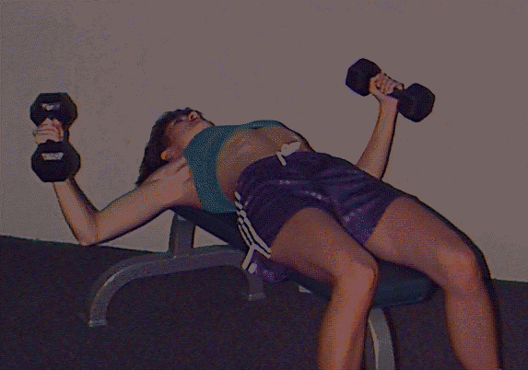
- Allow arms to move out in a wide arc
- Keep palms up and elbows pointed out
- Keep dumbbells in line with chest
- Lower dumbbell under control until they are level with your body
Upward Movement:
- Pull dumbbells up in a wide arc to your starting position above the chest
- Keep the elbows slightly flexed during the entire movement

Lateral Dumbbell Raise
Prime Movers/Muscles worked: Medial Deltoids, Trapezius
Beginning Position:
( can be standing or seated )
- Grasp dumbbells with palms at sides and facing in
- Bend elbows slightly
Upward Movement Phase: 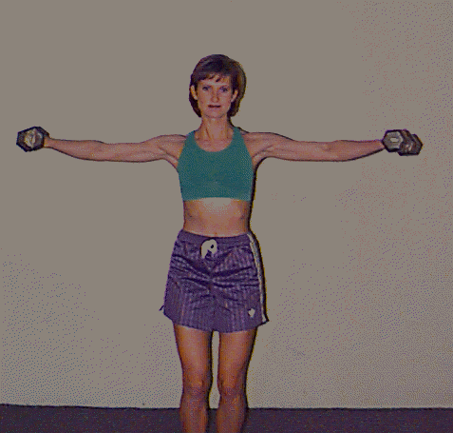
- Keeping your elbows bent at the same angle, slowly begin to raise the dumbbells to the side
- Stop the dumbbells as they reach shoulder level (palms should be facing the floor)
Downward Movement Phase:
- Slowly lower the dumbbells to the start position

One Arm Dumbbell Row
Prime Movers/Muscles worked: Rhomboids, Latissimus Dorsi, Biceps, Brachialis
Beginning Position: 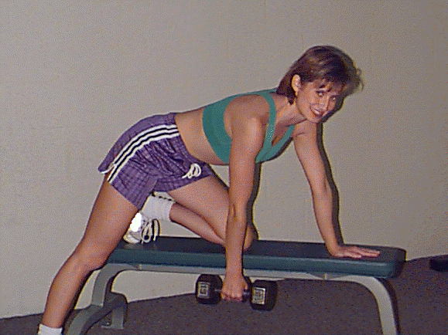
- Stand at the side of a bench
- Kneel on the bench with the leg that is next to it
- Lean over and place inside hand on the bench directly below your shoulder
- Place outside foot 1-2 feet from bench and flex knee
- Position body parallel to floor and grasp a dumbbell with your free hand
- Hang dumbbell down with arm straight
Upward Movement Phase:
- Pull dumbbell up toward the chest
- Keep body parallel to floor
- Touch dumbbell to outer chest
Downward Movement Phase:
- Lower dumbbell slowly and under control to a straight arm position.
- Maintain body position

Overhead Press
Prime Movers/Muscles worked: Anterior Deltoid, Triceps, Trapezius
Beginning Position: 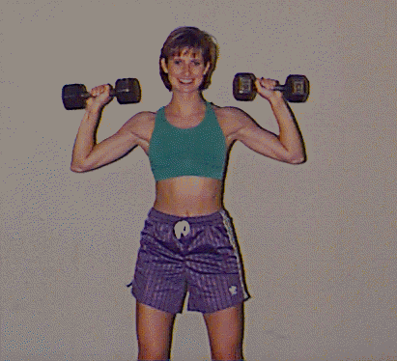
* best if started on a shoulder press rack
- Place bar on rests at a height at which when you slightly bend your knees the bar is level with the top of your shoulders
- Bend knees step up to the bar and grasp bar a little wider than shoulder width with palms facing away
- The bar should rest on your collar bone ( clavicle )
- Keep your upper back straight
- Keep a slight curve in your lower back
- Unrack bar with legs
Upward Movement Phase: 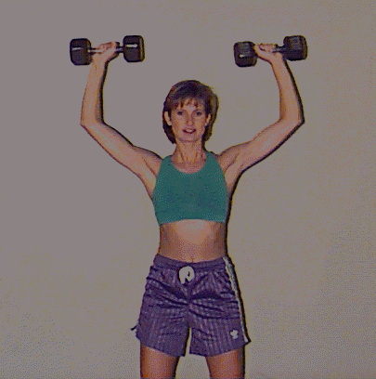
- Push bar up to full arm extension
- Keep elbows pointed out until arms are fully extended
- Maintain body position
Downward Movement Phase:
- Lower bar slowly and under control to your shoulders
- At the completion of the set, move bar to rack

