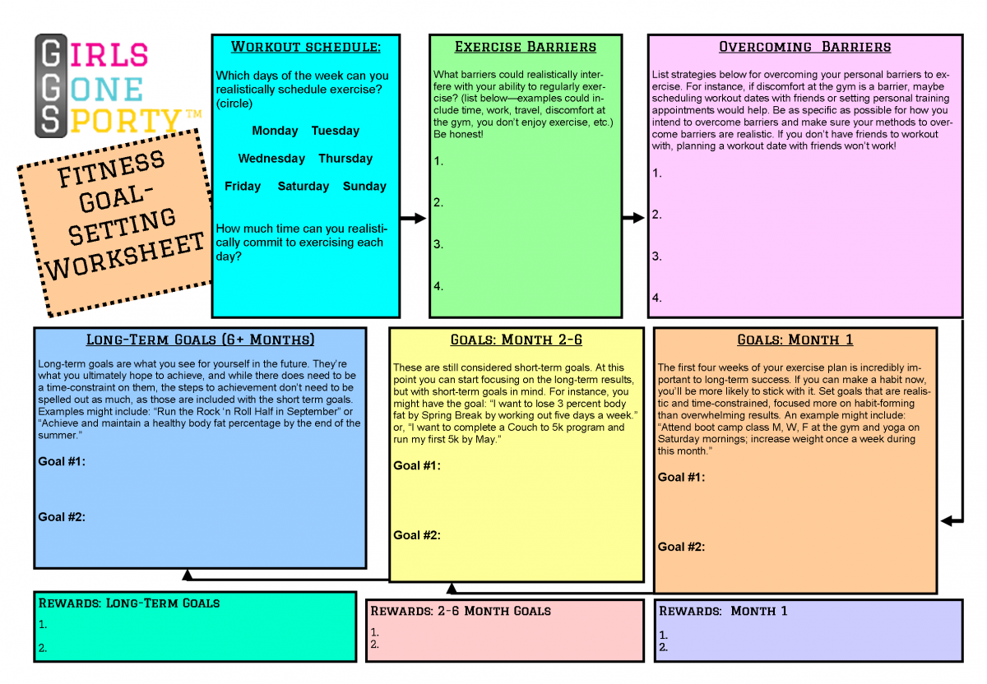
SHORT TERM- MARCH
MIDTERM - MAY
Grade 9
Physical
Education
FINAL- JUNE

Step | Concept | Description
1 | Specific  Exactly what is it you want to achieve? A good goal statement explains the what, why, who, where and when of a goal. If your goal statement is vague, you will find it hard to achieve because it will be difficult to define success.
2 | Measurable  You must be able to track progress and measure the result of your goal. A good goal statement answers the question, how much or how many. How will I know when I have achieved my goal?
3 | Acheivable  Is this an achievable goal? Why is this achievable?
4 | Realistic/relevant  Your goal should be stretching, but realistic and relevant to you. Make sure the actions you need to take to achieve your goal are things within your control? Why is this goal important to you?
5 | Time-Bound  Goals must have a deadline. A good goal statement will answer the question, when will I achieve my goal? Without time limits, it's easy to put goals off and leave them to die. As well as a deadline, it's a good idea to set some short-term milestones along the way to help you measure progress.

Partner Comments:_______________________________________________________________________________________ _________________________________________________________________________________________________________
____________________________________________________. Signature____________________________

COVER PAGE
Name
Date
Class
Picture Related to Action Plan

WORKOUT SCHEDULE:
Which days do you plan on working out during the week? Think about your current schedule are these days realistic for you? How much time can you realistically commit to this action plan?

BARRIERS (Pleas list 4 barriers):

OVERCOMING BARRIERS (Please list 4 solutions or ways that you can prevent the above barriers from becoming a problem when you are doing your action plan):

Short Term: SMART GOAL (written goal statement using the template)

Midterm: SMART GOAL (written goal statement using the template)

Long term: OVERALL GENERAL GOAL (This goal is more general not as specific)

Outcome 9.1

Create, implement, evaluate, and revise a personal fitness plan that illustrates the use of the principles of training and incorporates at least 30 consecutive minutes of moderate to vigorous activity on a daily basis.

 | Progressing (1) | Developing (2) | Meeting (3) | Exceeding (4)
Cover/ Title | Name is missing from cover page- Cover page is bear with no title | Title with little to no imagery. | Interesting title with some imagery. | Memorable title or catchy slogan. Well organized, colorful and captivating.
SMART Goal/ Challenge Statement | Goals are too broad and vague. | SMART goals are missing two elements. | Smart goals are missing only one element. | SMART goals are specific, measureable, attainable, realistic, and timely. Challenge statement is identified.
Start/ Stop Date | Only one date is provided and is vague. (Wednesday) | Both dates are vague. | Both dates are included but could be more detailed. | Both start and end dates are included; day, month, year (time)
Barriers/Solutions | Barriers and Solutions are not related and are not explained | There are 4 barriers or obstacles. solutions are basic and simple | There are 4 barriers or obstacles. The solutions are detailed and relevant. | There are 4 detailed barriers or obstacles. The solutions are reflective detailed and well thought out.

