LOWER BODY EXERCISES FOR SPLIT ROUTINE
WELLNESS 10 (Ms. Lynch)

Squat
Prime Movers/Muscle worked: Quadriceps (the muscles on the front of the upper leg), Hamstrings ( the muscles on the back of the upper leg), Gluteals, Hip Flexors, and Calf muscles.
Machine: Squat Rack
Beginning Position: 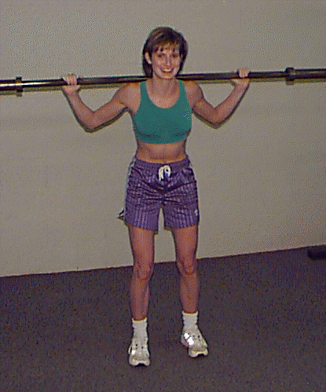
- Begin by placing the straight bar on the rack just below shoulder level
- Once the proper weights have been added, be sure to put a collar on each side of the bar to hold weights in place
- Step under the bar, making sure it rests on the area just below the base of your neck and between the shoulders (find the most comfortable spot)
- Place your hands around the bar on either side of your shoulders in a position that feels comfortable to you
- Place one foot in front of your upper body and one behind before lifting the bar of of the rack
- Once the bar has been removed, position your feet so they are shoulder-width apart
- Toes should point in the same direction as your knees
- The upper body should be straight and erect with head facing forward
- Abdominals should be slightly contracted to assist in keeping the back straight
For added safety it is recommended that a securely fastened weight belt be worn around the waist (specifically the low back) whenever squatting exercises are performed.
Downward Movement Phase: 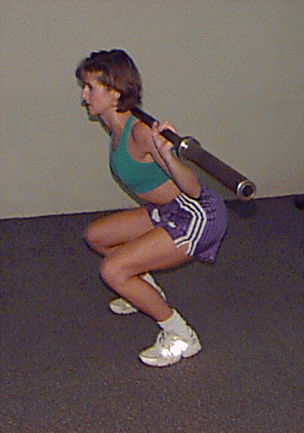
- Make sure to look forward and inhale during the entire movement
- Keeping both feet firmly on the floor begin lowering your body while bending at the hips (3-4 count) and forcing your buttocks out behind you
- Immediately after initiating the bend at the hips begin bending at the knees to lower your body toward the ground
- Make sure your knees do not pass over the front of your toes, if this occurs add more bending at the hip (It should look similar to a sitting movement)
- Concentrate on keeping your back perfectly straight and not leaning forward
- Lower your body until your upper leg becomes parallel to the floor
Upward Movement Phase:
- Make sure to look forward during the entire movement
- Keep both feet firmly on the floor and exhale during this phase
- Press into the floor evenly with both feet and straighten the legs in a smooth, controlled motion (3-4 count) making sure to keep your back straight
- Be sure to keep a slight bend in the knees at all times to avoid "locking" your knees
Return to the downward movement phase instructions and repeat the same movement.

Lunge
Prime Movers/Muscles Worked: Quadriceps (the muscles on the front of the upper leg), Hamstrings ( the muscles on the back of the upper leg), Gluteals, Hip Flexors, and Calf muscles.
Machine: None Required, Can be done with body weight or hand-held weights
Beginning Position: 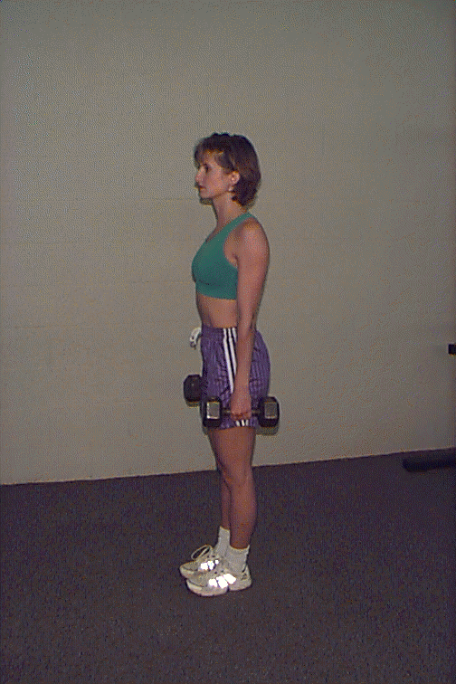
- Feet shoulder width apart with toes pointing forward
- Upper body erect, head facing forward with arms down at the side
Downward Movement Phase: 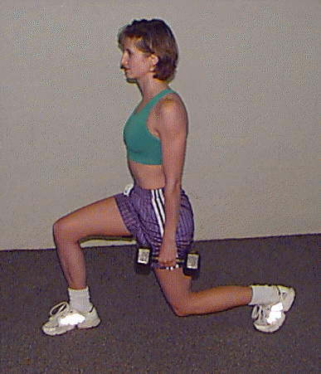
- With the right foot take a large step forward while keeping the left foot in place
- The right foot should be placed far enough forward that the knee does not pass over the front of the foot during this exercise
- Once the right foot is firmly on the floor lower the upper body by bending at the right knee (3-4 count) until the upper leg is parallel to the floor
- While bending at the right knee the left foot remains in place by shifting your weight to the left toes
- The left knee should bend slightly to assist in lowering the body but should not touch the floor
Upward Movement Phase:
- Push with the right foot into the floor in an upward and backward direction (3-4 count) in order to raise the body into an erect posture
- Be careful to maintain a smooth, controlled movement while returning to the starting position to avoid losing your balance
You are now in the beginning phase and can repeat the movement with the left foot forward

Leg Extension
Prime Movers/Muscle worked: Quadriceps (the muscles on the front of the upper leg)
Machine: Leg extension
Beginning Position: 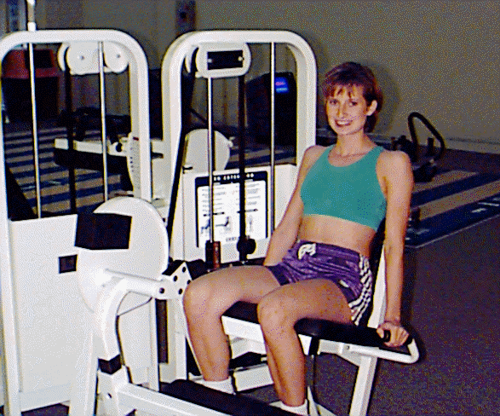
- Place proper resistance on the weight stack
- Assume a sitting position on the machine
- Place ankles of both legs behind leg bar so that the bar is in contact with the leg just above the foot
- Align knees with the axis of the machine
- Grasp handles (or seat) located on the side of the seat
- Keep upper body straight and supported by the machines back support
- Keep back flat against back support pad
Upward Movement Phase: 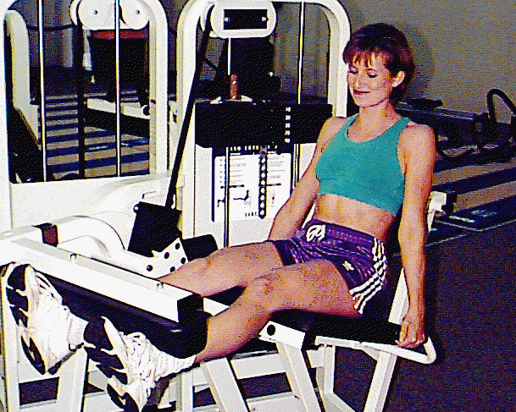
- Lift the legs/feet so that they are straight out in front of you
- Lift weight slowly and under control (3-4 count)
- Maintain proper alignment with back supported during all phases
- Remain seated throughout exercise
- Exhale while lifting or at the sticking point
Downward Movement Phase:
- Lower weight slowly (3-4 count) and under control to starting position without allowing the weight stack to rest
- Remain seated and continue to have back supported

Leg Curl
Prime Movers/Muscles worked: Hamstrings (the muscles on the back of the upper leg)
Machine: Leg curl (hamstring curl) Leg curl machines can be supine (lying on your stomach to do the exercise) or upright (seated with back supported) depending on the equipment available. Both are described below.
SUPINE MACHINE
Beginning Position:
- Place proper resistance on machine
- Lie with stomach against bench
- Position body so that hips and chest are flat against the bench
- Place ankles under leg pad with pad just above the heel
- Place knees so that they are just off the bench
- Align knees with the axis of the machine
- Grasp handles with hands
Upward Movement Phase:
- Maintain body position on bench and leg pad
- Keep hips and chest in contact with bench
- Flex the knees so that heels come toward the buttocks
- Heels and leg pad should come as close as possible to the buttocks
- Raise the weight slowly (3-4 count) and under control
- Exhale on lift
Downward Movement Phase:
- Maintain body position with back supported
- Slowly lower (3-4 count) the leg bar to the starting position under control
- Keep weight stack from resting against unused stack of weights
- Inhale during downward movement phase

Calf Raise
Prime Movers/Muscles Worked: Gastrocnemius (calf muscle), Soleus (under the calf muscle)
Machine: Seated Calf Raise or Upright Calf Raise with Body Weight

